**Assignment -3**

Cloud object storage and Watson assistant

|  |  |
| --- | --- |
| Assignment Date | 30 September 2022 |
| Student Name | K.Muthu Ramalingam |
| Student Register Number | 950519106017 |
| Maximum Marks | 2 Marks |

**Question-1:**

Create a Bucket in IBM object storage

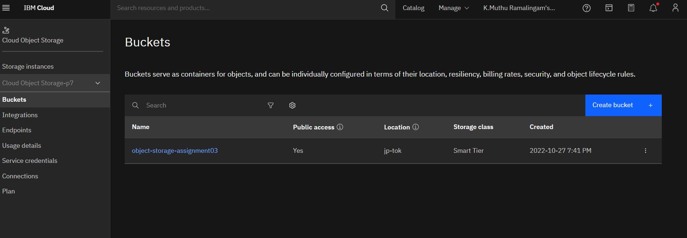

**Question-2:**

**Upload an 5 images to ibm object storage and make it public. Write html code to displaying all the 5 images.**

HTML CODE:

<!DOCTYPE html>

<html>

<head>

<link rel="stylesheet" href="https://object-storage-assignment03.s3.jp-tok.cloud-object-storage.appdomain.cloud/assignment3.css">

</head>

<body>

<h1>This images are from the cloud object storage</h1>

<div class="grid-container">

    <div class="item1"><img src="https://object-storage-assignment03.s3.jp-tok.cloud-object-storage.appdomain.cloud/1.jpg" alt="Car"></div>

  <div class="item2"><img src="https://object-storage-assignment03.s3.jp-tok.cloud-object-storage.appdomain.cloud/2.jpg" alt="Car"></div>

  <div class="item3"><img src="https://object-storage-assignment03.s3.jp-tok.cloud-object-storage.appdomain.cloud/3.jpg" alt="Car"></div>

  <div class="item4"><img src="https://object-storage-assignment03.s3.jp-tok.cloud-object-storage.appdomain.cloud/4.jpg" alt="Car"></div>

  <div class="item5"><img src="https://object-storage-assignment03.s3.jp-tok.cloud-object-storage.appdomain.cloud/5.jpg" alt="Car"></div>

</body>

</html>

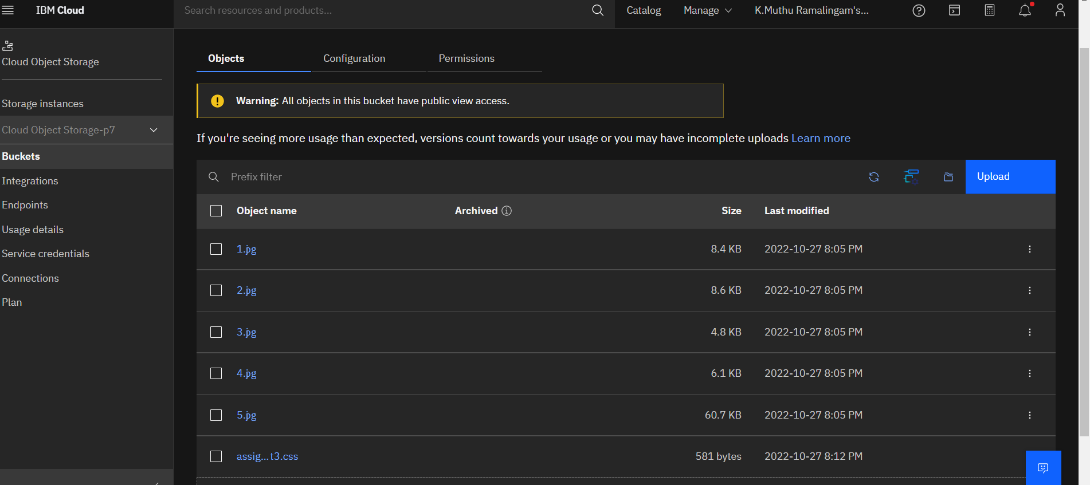

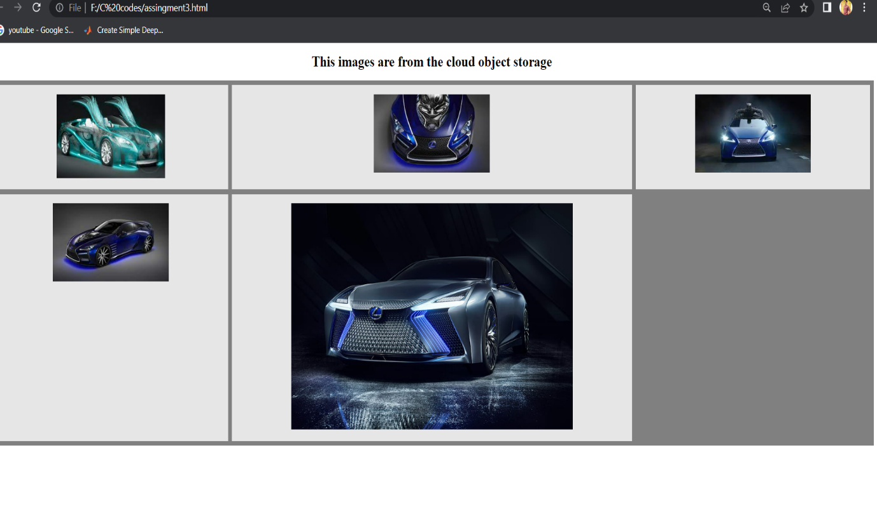

**Question-3:**

Upload a css page to the object storage and use the same page in your html code.

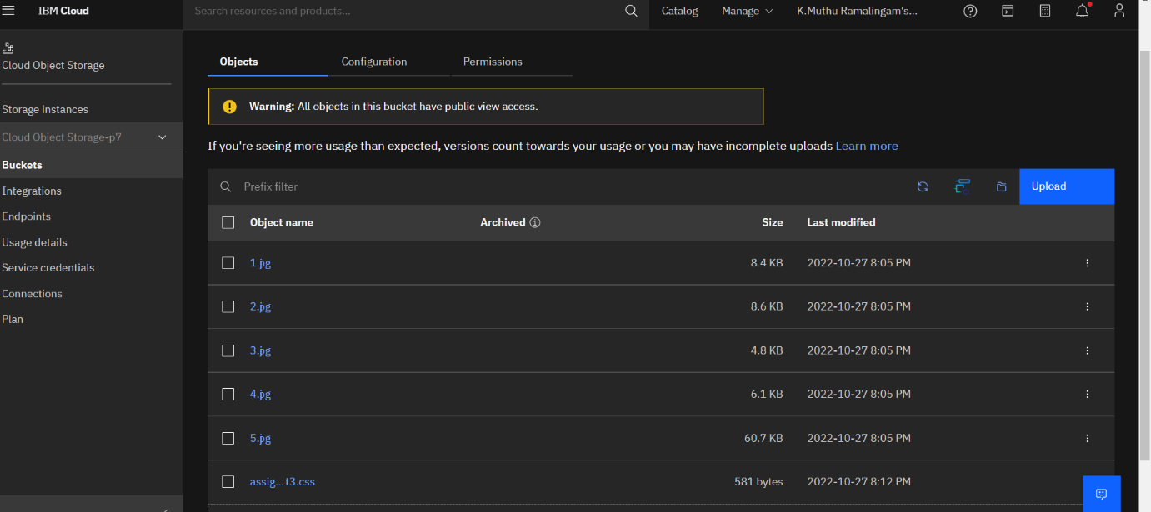

Css page used in html page

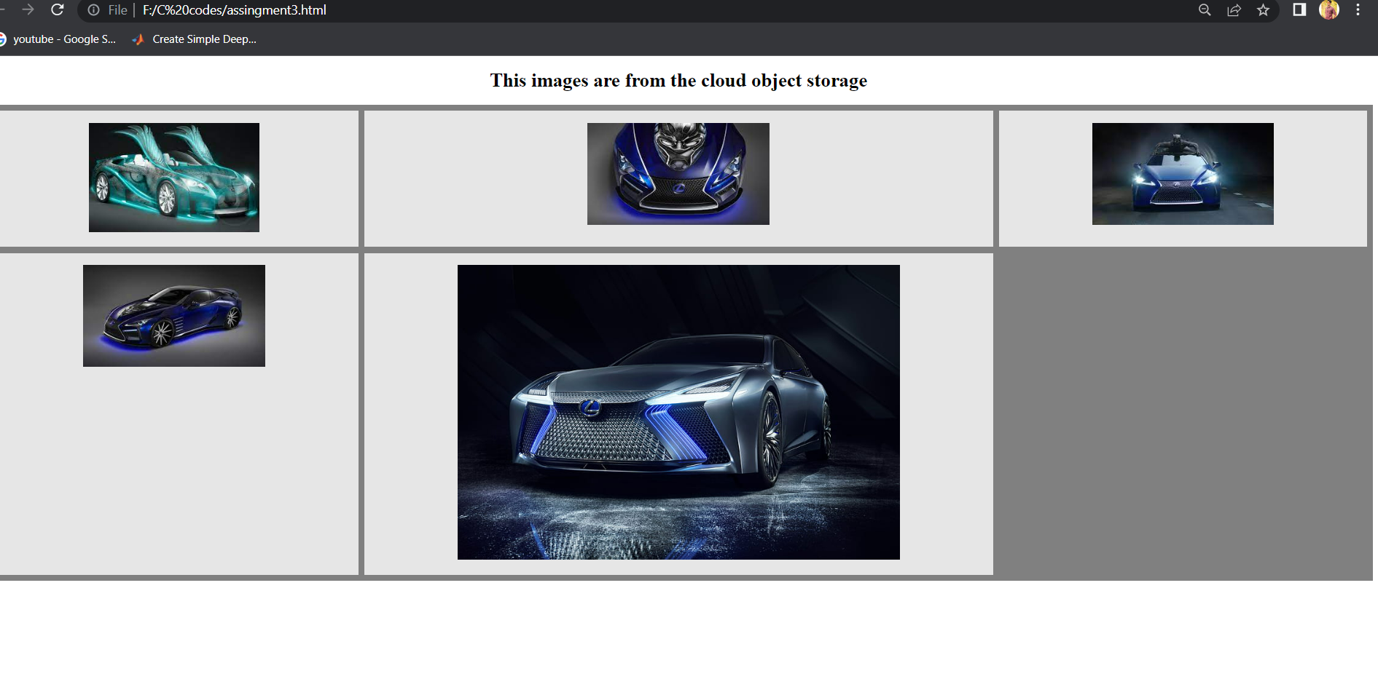

**Question-4:**

Design a Chabot using IBM Watson assistant for hospital. Ex: User come the query to know the braches for that hospital in your city.

URL link for chatbot: https://au-syd.assistant.watson.cloud.ibm.com/crn%3Av1%3Abluemix%3Apublic%3Aconversation%3Aau-syd%3Aa%2F877425929dc344bcb74ff781790e02f3%3A8552cfca-f6ea-47de-818c-a148df12d10e%3A%3A/assistants/f0c2b51b-bc3e-4ba1-ad66-da22d28a5c31/preview

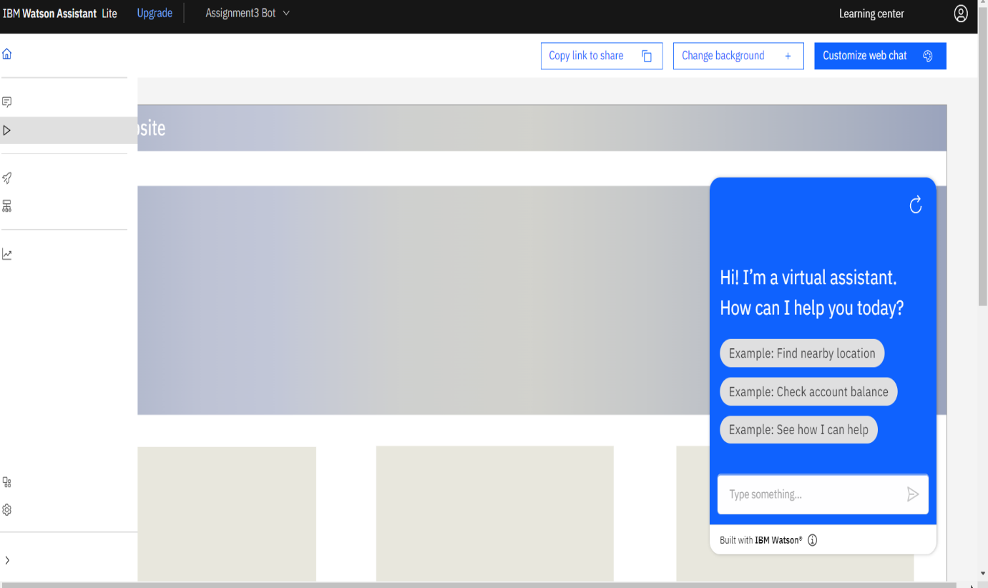

**Question-5:**

Create Watson assistant service with 10 steps and use 3 conditions in it. Load that script in html page.

<!DOCTYPE html>

<html>

<head>

<link rel="stylesheet" href="https://object-storage-assignment03.s3.jp-tok.cloud-object-storage.appdomain.cloud/assignment3.css">

</head>

<script>

  window.watsonAssistantChatOptions = {

    integrationID: "0b305951-d464-4f72-9cc7-938932287427", // The ID of this integration.

    region: "au-syd", // The region your integration is hosted in.

    serviceInstanceID: "0516420a-a54c-4626-b459-481c71f5ac41", // The ID of your service instance.

    onLoad: function(instance) { instance.render(); }

  };

  setTimeout(function(){

    const t=document.createElement('script');

    t.src="https://web-chat.global.assistant.watson.appdomain.cloud/versions/" + (window.watsonAssistantChatOptions.clientVersion || 'latest') + "/WatsonAssistantChatEntry.js";

    document.head.appendChild(t);

  });

</script>

<body>

<h1>This images are from the cloud object storage</h1>

<div class="grid-container">

    <div class="item1"><img src="https://object-storage-assignment03.s3.jp-tok.cloud-object-storage.appdomain.cloud/1.jpg" alt="Car"></div>

  <div class="item2"><img src="https://object-storage-assignment03.s3.jp-tok.cloud-object-storage.appdomain.cloud/2.jpg" alt="Car"></div>

  <div class="item3"><img src="https://object-storage-assignment03.s3.jp-tok.cloud-object-storage.appdomain.cloud/3.jpg" alt="Car"></div>

  <div class="item4"><img src="https://object-storage-assignment03.s3.jp-tok.cloud-object-storage.appdomain.cloud/4.jpg" alt="Car"></div>

  <div class="item5"><img src="https://object-storage-assignment03.s3.jp-tok.cloud-object-storage.appdomain.cloud/5.jpg" alt="Car"></div>

</body>

</html>

Output:

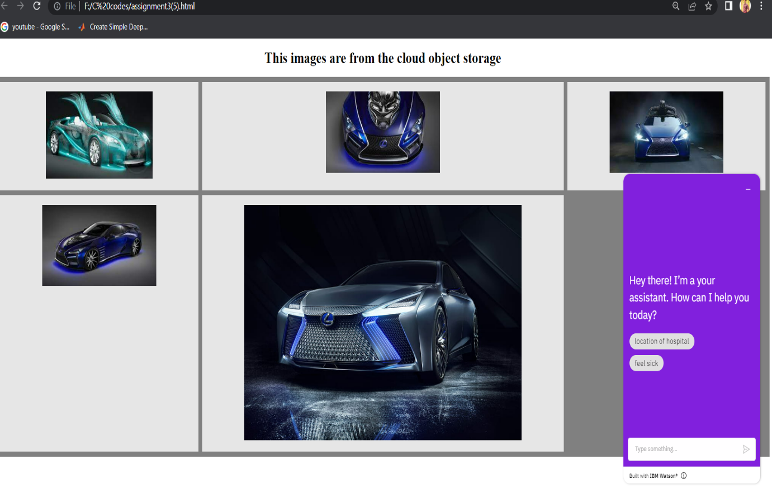

URL link for chatbot: https://au-syd.assistant.watson.cloud.ibm.com/crn%3Av1%3Abluemix%3Apublic%3Aconversation%3Aau-syd%3Aa%2F877425929dc344bcb74ff781790e02f3%3A8552cfca-f6ea-47de-818c-a148df12d10e%3A%3A/assistants/f0c2b51b-bc3e-4ba1-ad66-da22d28a5c31/preview